|  |  |
| --- | --- |
| **jnj_InformationTechnology_logo_preferred_RGB_2color** | |
| Finance |
| EMEA Invoice Extract & Deliver  Solution Design Definition |
| SDLC-122377  RPA-EMEA Invoice Extract Process  VERSION: 1.0 |

|  |  |  |
| --- | --- | --- |
| Role | Name and title | Signature and Date |
| Author: | | |
| Technical Architect  Technical Architect QA | Venkatesh Murthy B R Nitesh Srivastava  Neil Mack |  |
| Review and approval: | | |
| Business Product Owner | Brice Nielsen |  |
| Solutions Lead | Gloria Ramos |  |
| RPA Service Owner | Shahriar Mamun |  |
| Technical Product Owner | Andrew Whitten |  |

Table of Contents

[1 Purpose 5](#_Toc101860514)

[2 Definitions 5](#_Toc101860515)

[3 References 6](#_Toc101860516)

[4 Process Design 7](#_Toc101860517)

[4.1 Process Flow 7](#_Toc101860518)

[4.1.1 Source System(s) 7](#_Toc101860519)

[4.1.2 Target System(s) 7](#_Toc101860520)

[4.1.3 Main Process Diagram and Page Design 8](#_Toc101860521)

[4.1.3.1 Main Process Diagram 8](#_Toc101860522)

[4.1.3.2 Main Process Page Design 8](#_Toc101860523)

[4.1.4 Sub-Process 12](#_Toc101860524)

[4.1.4.1 Sub-Process Diagram 12](#_Toc101860525)

[4.1.4.2 Sub-Process Page Design 13](#_Toc101860526)

[4.2 General Design Considerations 14](#_Toc101860527)

[4.2.1 Bot Process Solution 14](#_Toc101860528)

[4.2.1.1 Bot receives email 14](#_Toc101860529)

[4.2.1.2 Bot reads & validate Excel Template 14](#_Toc101860530)

[4.2.1.3 Bot creates Processing Sheet Excel File and loads the data to BP Queue 15](#_Toc101860531)

[4.2.1.4 Bot determines department 16](#_Toc101860532)

[4.2.1.5 Bot processes Pharm Request 17](#_Toc101860533)

[4.2.1.5.1 Determines invoice # from purchase order # 17](#_Toc101860534)

[4.2.1.5.2 Search for invoice copy via invoice # 19](#_Toc101860535)

[4.2.1.5.3 Save PDFs to local 20](#_Toc101860536)

[4.2.1.5.4 Update SAP with confirmation invoice sent 23](#_Toc101860537)

[4.2.1.6 Bot processes MD P01 Request 24](#_Toc101860538)

[4.2.1.6.1 Determine MD P01 and MD Mass Reprint requests 24](#_Toc101860539)

[4.2.1.6.2 Searches for invoice or credit note 24](#_Toc101860540)

[4.2.1.6.3 Saves PDF to local 25](#_Toc101860541)

[4.2.1.6.4 Bot processes Mass Reprint Request 25](#_Toc101860542)

[4.2.1.6.5 Drag & Drop to pathway 26](#_Toc101860543)

[4.2.1.6.6 Saves PDF from email link 27](#_Toc101860544)

[4.2.1.7 Bot creates list of updates for Get Paid 28](#_Toc101860545)

[4.2.1.8 Consolidate files 29](#_Toc101860546)

[4.2.1.9 Email invoice back to collector 31](#_Toc101860547)

[4.3 Bot Solution Design 32](#_Toc101860548)

[4.3.1.1 Single or Multi-Bot Solution 33](#_Toc101860549)

[4.3.1.2 Application Availability 34](#_Toc101860550)

[4.3.1.3 Bot Runner Requirement (Based on AS-IS Input) 34](#_Toc101860551)

[5 Exceptions 35](#_Toc101860552)

[5.1 Known Exceptions 35](#_Toc101860553)

[5.2 Unknown Exceptions 38](#_Toc101860554)

[6 Object Design 39](#_Toc101860555)

[6.1 Shared Objects 39](#_Toc101860556)

[6.1.1 Shared Object Changes 39](#_Toc101860557)

[6.2 Custom Objects 39](#_Toc101860558)

[7 Data 42](#_Toc101860559)

[7.1 Environment Variables 42](#_Toc101860560)

[7.2 Session Variables 42](#_Toc101860561)

[8 Credentials 43](#_Toc101860562)

[8.1 Credential Management 43](#_Toc101860563)

[8.2 Application Access Details 43](#_Toc101860564)

[Application Installation 44](#_Toc101860565)

[8.3 Target Applications Access 44](#_Toc101860566)

[9 Reporting and Monitoring 44](#_Toc101860567)

[10 Alerts 44](#_Toc101860568)

[10.1 Controller/Admin 45](#_Toc101860569)

[10.2 Process Owners 45](#_Toc101860570)

[10.3 Support Team 45](#_Toc101860571)

[11 Management Reporting Details 45](#_Toc101860572)

[12 Operational and Deployment Requirements 45](#_Toc101860573)

[12.1 Schedule and Operating Hours 45](#_Toc101860574)

[13 Application Model 46](#_Toc101860575)

[14 Information Security and Risk Management 47](#_Toc101860576)

[Business Continuity Plan 47](#_Toc101860577)

[Risk Management 47](#_Toc101860578)

[14.1 Information Security Audit and Compliance requirement 48](#_Toc101860579)

[14.2 Logging 48](#_Toc101860580)

[15 Data Validation 48](#_Toc101860581)

[Data Flow 48](#_Toc101860582)

[16 Additional Assumptions 49](#_Toc101860583)

[Technical 49](#_Toc101860584)

[Business 49](#_Toc101860585)

[17 Revision History 50](#_Toc101860586)

# Purpose

This document contains the solution design details of an automation in Blue Prism. This document translates the keystroke level process into an overarching design to minimize development effort and maximize object reusability. The intended audience for this document is initially the RPA development team who will refer to this document for the build of the automation, then later the operations and support team as a reference to the solution.

This document details production information about the process, technical details and environment which may be relevant during development. It captures all inputs, outputs, environmental factors, schedules, SLAs, alert structures, reporting targets, and any other requirements of the business process in sufficient detail to be able to ensure that all requirements at all levels are met.

**1.1 Scope**

The scope of the automation is to extract invoice copies using Mass Reprint or SAP Galaxy/P01 when requested by collectors for MD and Pharm.

The purpose of using RPA will be to automate the invoice extract process by:

1. Receiving requests for invoice extraction in an email with an excel template attached. This Excel file will have the details of the invoices to be extracted
2. Searching for invoices through Mass Reprint or SAP
3. Downloading the PDF files to a local drive
4. Consolidating PDF files into single PDF
5. Emailing invoices back to the collector

# Definitions

| Term/Acronym | Definition |
| --- | --- |
| RPA | Robotic Process Automation |
| BP | Blue Prism |
| I2C | Invoice to Cash |
| QC | Quality Check |
| MD | Medical |
| Pharm | Pharmaceutical |
| PO | Purchase Order |
| SO | Sales Order |
| FRA | Functional Requirements Analysis |
| SME | Subject Matter Expert |
| SLA | Service Level Agreement |
| Digital Worker, Software Robot or Bot | The software (Blue Prism) code that executes a process (transaction or group of transactions) that replicates a human |

# References

| Document ID | Title |
| --- | --- |
|  | RPA Functional Requirements |
| ProcessConfigFile | Configuration Excel File which would have all the Input |
|  | Mass Reprint Template |
|  | Input Sheet from email |
|  | Bot Processing sheet |
|  | Get Paid Excel |

# Process Design

## Process Flow

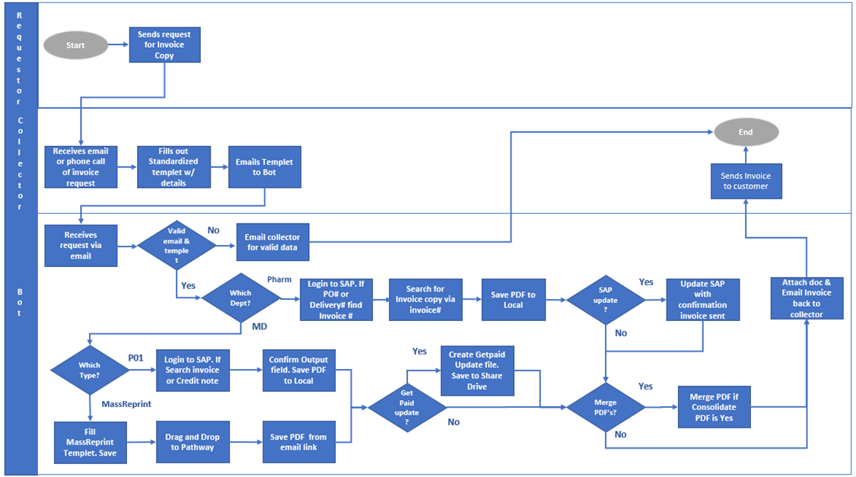

### Source System(s)

|  |  |
| --- | --- |
| Source System Name | Data Output |
| SAP (Galaxy and P01) | Bot needs to log into SAP portals to search and extract invoice copies |
| Mass Reprint | Bot will use pathway to generate invoice & credit notes for MD |
| Shared Drive | Save Get Paid update file |
| MS Outlook | To send invoice |
| Adobe Acrobat DC | To Merge PDF files |
| Oracle OLEDB | To Validate Customer |

### Target System(s)

|  |  |
| --- | --- |
| Target System Name | Data Input |
| MS Excel | Read |

### Main Process Diagram and Page Design

Process Name: GL\_FIN\_I2CInvoiceExtraction

|  |  |  |  |
| --- | --- | --- | --- |
| Process Name | Component Type | Comments/Values | Reusability |
| GL\_FIN\_I2CInvoiceExtraction | Process Object | This is the Main Entry Process and will handle Work Steps to process requests | New |
| GL\_FIN\_I2C\_Input Sheet Validation | Process Object | This process will perform validation steps on Excel Input Sheet | New |
| GL\_FIN\_I2C\_InvoiceExtraction\_ProcessingSheetCreation | Process Object | This process will create the processing sheet with each line-item detail | New |

#### Main Process Diagram

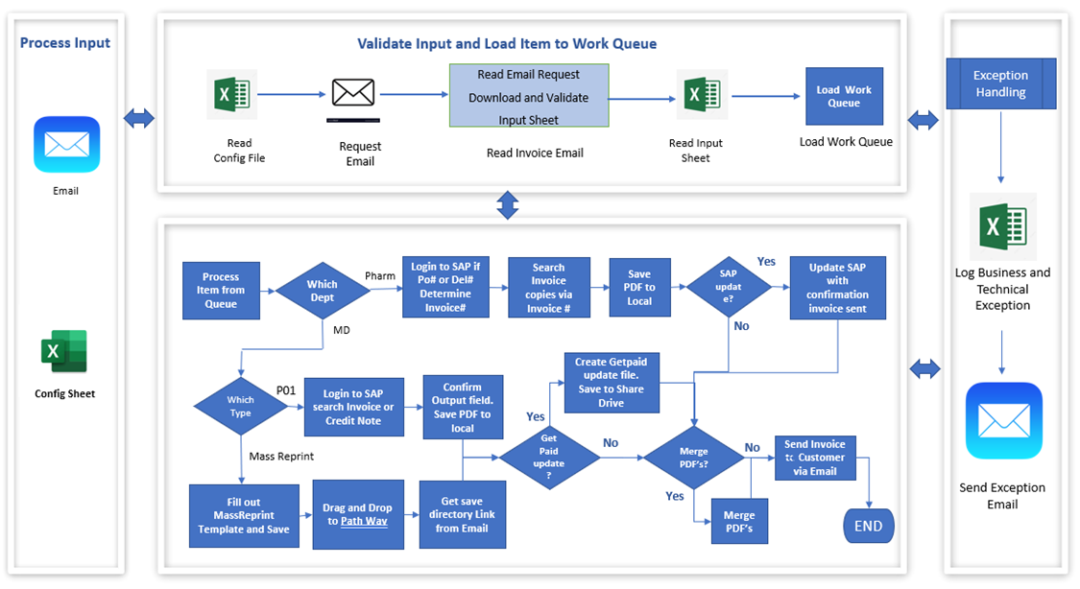

#### Main Process Page Design

|  |  |  |
| --- | --- | --- |
| Page Name | Page Description | Inputs / Outputs |
| Main page | This is the Main Entry Process. It will read the Bot. Config File and Invoke Data Process. | N/A |
| 1.0 Start Up | This is to get the process config details and delete pending items | N/A |
| 1.1 Load Config Parameter | This page is responsible for setting up all the mandatory config parameters required to process the request. | I/P – ConfigFilePath, Worksheetname |
| 1.2 Delete Pending Items | This page is responsible for setting up all the mandatory config parameters required to process the request. | N/A |
| 1.2.1 CheckCurrentTime | This is to get the current time to delete the pending items only from previous day | O/P - DeleteFlag |
| 2. Input Validation | This Page is responsible to validate the input file received and create processing file with all transactions. | O/P – colProcessingData, EmailDetails |
| 2.1 Duplicate check | This page is responsible to check if duplicate exists | I/P – InputCollection. Filepath  O/P - UniqueValues |
| 2.1.1 Duplicate | This page is responsible to send email on duplicate case to collector | I/P – ExceptionCol. EmailSubject |
| 2.2 SetProcessingData | This page is responsible to set the details for processing file. | I/P - TempProcessingSheet |
| 2.2.1 ProcessingSheetCreation | This page is responsible to create the processing file if not exists and update existing one if it is present. | I/P - ColProcessingCreation |
| 2.3 SetProcessingData | This page is responsible for clearing data for processing Sheet creation | I/P - ColProcessingData |
| 2.3.1 ProcessingSheetCreation | This Page is responsible for creating Processing Sheet | I/P – ColProcessingCreation |
| 2.4 Flow Logic | This Page is responsible for Separating Flow Data if either of the flow not working | I/P- Flow  I/P – InputCollection |
| 3 MD Process | To set data for MD request type | I/P – ColProcessing  O/P - ColProcessing |
| 3.1 MDFilterCollection | This page is responsible to check if invoices exist for given customer | I/P-InCollection, ColumnName  O/P - ColProcessing |
| 3.1.1 GetDatafromDatabase | This page is responsible to run SQL query to confirm that invoices are present or not | I/P – SQLQuery. TempCollection  O/P – SQLData |
| 3.1.1.1 OLEDB | This page is responsible to run the OLEDB connection | I/P – SQLQuery  O/P-Results |
| 4. PopulateQueue | This Page is responsible for processing the Invoice Request details added to Work Queue. | I/P-ColQueueData. txtqueueKeyFieldName. txtQueueName, flagCheckAlreadyExistItem. txtQueueTagName. txtQueueStatus  O/P-Success |
| 5 MD Request | This page is responsible to process MD requests | I/P – ItemData, Processingdata |
| 5.1 Mass Reprint | This Page is responsible to run the mass reprint request | I/P – Item Data |
| 5.2 P01Requests | This Page is responsible to run P01 requests | I/P – Item Data |
| 5.2.1 Get Paid | This Page is responsible to check if get paid is yes and then it will create get paid file | I/P – Item Data |
| 5.2.2 Merge PDF | This page is responsible to merge download PDF | I/P – InputPath, OutPath |
| 6.0 Get & Update Invoice | This page is responsible to extract invoice from SAP | I/P - ColFinalProcessing |
| 6.1 SetTcode | The page is responsible to set the Tcode value. | N/A |
| 6.2 Get Invoice | This page is responsible to extract invoice | N/A |
| 6.2.1 CheckSAPSystem | This Page is responsible to check which SAP system need to be executed | N/A |
| 6.2.2 ERP Launchpad Launch & Login | This Page is responsible to launch ERP and login into same | N/A |
| 6.2.3 SAP SSO-ERP | This page is responsible to check is SSO is performed from ERP | O/P - Success |
| 6.2.4 SAP SSO | This Page is responsible to login into SAP using SAP Logon | O/P - Success |
| 6.2.5 Run VA05 | This Page is responsible to extract invoice number based on Purchase Order Number | N/A |
| 6.2.6 Run VL03N | This Page is responsible to extract invoice number based on delivery number | N/A |
| 6.2.7 SAP Logout | This Page is responsible to perform SAP logout | N/A |
| 7.0 Download Invoice | This page is responsible to download invoice | N/A |
| 7.1 Download PDF | This page is responsible to download PDF | N/A |
| 7.2 Run VF31 | This page is responsible to download invoice copy from VF31 using invoice number | N/A |
| 7.2.1 Create Subfolder | This page is responsible to create subfolder where PDF are downloaded | I/P -DirectoryPath, FolderCreationPath  O/P - SavePDFPath |
| 7.3 Run YFT\_FFAR00 | This page is responsible to update status code and comment for given invoice | N/A |
| 8.0 SplitInvoice - MD | This page is responsible to split MD invoices | I/P- ProcessingData, Item Data |
| 9.0 Update Q | This page is responsible to update case status in queue | I/P – TagText, UntagText, Defer? DeferUntil, Release?, Completed?, ExceptionType, ExceptionDetails,ExceptionStage  O/P - NewItemID |
| 10 Clean Up | This page is responsible to close down all the opened instance of application | N/A |
| 11 Send Exception Email | This page is responsible to send exception email | I/P – Item Data |
| 11.1 Exception Log | This page is responsible to create the exception log file and update exception details | I/P – Item Data,ExceptionDetails |
| 12 Update PS and InputFile | This page is responsible to update status of invoice in the processing sheet and invoice file | I/P – Item Data |
| 12.1 UpdateInvoice-PS MD | This page is responsible to update the invoice status in processing sheet for MD | N/A |
| 12.2 UpdateInvoice – MD | This page is responsible to update the invoice status in input sheet for MD | N/A |
| 12.3 UpdateInvoice-PS-PHM | This page is responsible to update the invoice status in processing sheet for pharma | N/A |
| 12.4 Update InputFile | This page is responsible to update the invoice status in input sheet for pharma | N/A |
| 13 Move Emails | This page is responsible to move email to subfolder as per status | I/P - EmailDetails |
| 14 Reset Global Variables | This page is responsible for resetting the global variables data | N/A |
| 15 check and move PDF | This page is responsible to move PDFs in different folder if count is more than 10, Zip the files and Send Emails | N/A |
| 15.1 Get Data from Processing Sheet | This page is responsible for read the processing Sheet Data | N/A |
| 15.2 Check Merge PDF folder | This page is responsible for Merge PDF based on Collector | I/P-EmailItems  I/P-TempCollection |
| 15.2.1 MoveMergePDFs | This Page is responsible for Move Merged PDFs to Share drive | I/P- MergePDF  I/P-EmailAddress-RT |
| 15.3 Get EntryID and FileName | This Page is responsible for Get EntryId and FileName from Queue based on Activity | I/P- ActivityNumber |
| 15.4 Move PDFs and Send Email | This Page is responsible for move PDFs and send email to collectors | I/P- FolderPath  I/P- SenderEmailAddress  I/P-FileName  I/P-MergedPDF  I/P-EmailAddress-RT |
| 15. 4.1 ZIP Folder | This Page is responsible for Zipping the folder of 10Files | I/P-DirectoryPath  I/P-Files  I/P MaxLimit  I/P-MergePDF |
| 15.4.2 UpdateWorkQueue | This Page is responsible for Updating the work Queue based on Activity | I/P-QueueMArkCollection  I/P-EmailID  I/P-Completed  I/P-Release  I/P-ExceptionType |
| 15.4.2.1 UpdateProcessignSheet | This Page is responsible for Updating Status in Processing Sheet | I/P-FiledStatus  I/P-ActivityNumber |
| 15.5 MoveEmails | This Page is responsible for moving email based on Status | I/P- EntryID  I/P-ExceptionStatus-Check  I/P-ExceptionStatus-Move |
| 16 IRIS | This Page is responsible for Create Queue in IRIS | I/P-ResourceWWID |

### Sub-Process

Sub-Process Name: GLFIN\_I2C\_InvoiceExtraction\_ProcessingSheetCreation

GL\_FIN\_I2C\_InvoiceExtraction\_InputSheetValidation

#### Sub-Process Diagram

* GL\_FIN\_I2C\_InvoiceExtraction\_InputSheetValidation
* GL\_FIN\_I2C\_InvoiceExtraction\_ProcessingSheetCreation

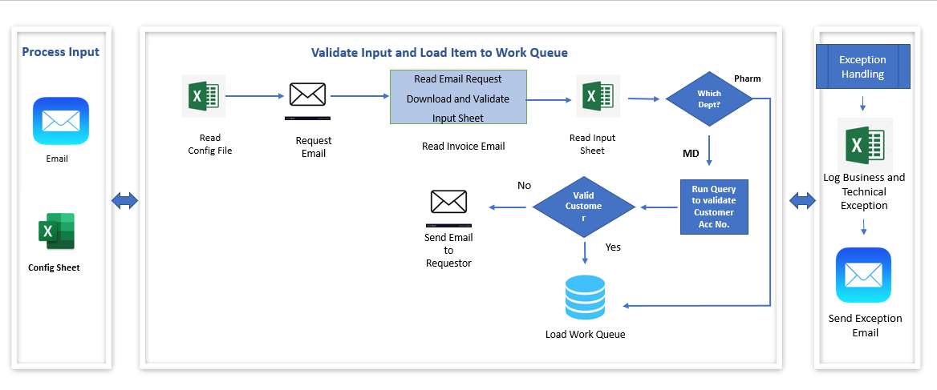

#### Sub-Process Page Design

GL\_FIN\_I2C\_InvoiceExtraction\_ProcessingSheetCreation

|  |  |  |
| --- | --- | --- |
| Page Name | Page Description | Inputs / Outputs |
| Main Page | This is the Main Entry Process. | I/P- InputFIlePath, SenderEmailAddress  O/P- ProcessingDetails, NoData |
| ReadInput\_ExcelData | This Page is responsible to read excel and set the data for processing sheet | I/P- ExcelFilePath, SenderEmailsAddress  O/P- ProcessingSheet, NoData |

GLFIN\_I2C\_Input Sheet Validation

|  |  |  |
| --- | --- | --- |
| Page Name | Page Description | Inputs / Outputs |
| Main Page | This is the Main Entry Process | I/P – RsourceName  User  Config\_Collection  O/P – Items,ItemCount,Success |
| ValidateAttachment | This Page is responsible to validate attachment of emails. | I/P – SubdolderPath, ItemDetails, MacroFilePath, MacroName, SetStatusMacro |

## General Design Considerations

### Bot Process Solution

#### Bot receives email

Bot receives a request via email with excel template attached. As a sequence, the bot will follow a first in first out processing setup. A shared mailbox email ID will be created for the bot and will be shared across multiple bot machines.

**Bot Validates Email**

1. **Collector’s email ID**: the bot will only process request coming from a JNJ email (JNJ.com).
2. Validate if there is a valid excel attachment, else bot must raise exception and reply to email with exception message
3. **Invalid** requests will be saved to an exception folder. Exception details will include: JNJ email validation result and invalid document attachment

#### Bot reads & validate Excel Template

Bot downloads the excel file to the share drive. Bot will validate the input excel.

1. Either Invoice Number, Delivery Number or Purchase Order Number should be provided if any one of the values is not provided, then bot must raise an Exception
2. Document Type should be 2 chars
3. Company code should be 4- or 5-digits number.
4. Value for Requires Get Paid Update, Requires SAP Update, consolidate files should be Yes or No. If blank bot should still process considering it as No
5. If any of the validation fails as per above bot should update a column in Input sheet as Comment and update exception comment for each row.
6. Bot to reply to email attaching the updated Input Sheet with exception comments to resubmit the request post correction.



Once the validation is complete Bot reads the data from the excel and adds it to the BP queue for further processing.

#### Bot creates Processing Sheet Excel File and loads the data to BP Queue

Bot to create a Processing excel-sheet each day in share drive with below fields.

Bot reads the data from the input sheet and adds the data to the Processing sheet.



Bot identifies the type of request - Pharm vs MD (refer to 4.2.1.4) and updates the request type.

If request type is Pharm,

* 1. Add the line item to Processing Sheet and BP Queue
  2. Set Request Type to Ph

If request type is MD,

* 1. Validate customer account no. by querying ODBC connection.
  2. Use Customer account no, document no, and doc type to return results.

Note: Document number is the invoice number in query as per Input Sheet

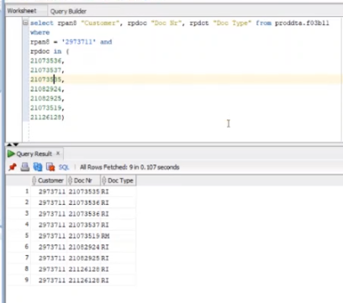

* 1. If the result is not returned, or miss match in Document number between the Query result and input sheet then
* Reply to the Preparer the invoice could not be extracted with those given values.

else

* + - * The bot will determine P01 or Mass Reprint Request (refer 4.2.1.6.1) updates the request type.
* P01 – P01 request Type
* MR – Mass Reprint Request
  + - * If request type is Mass Reprint Request (MR), bot will group all the Mass Reprint Request and sets Key value for 1st line item to 1 and remaining line item to 0.
  1. Add the data to Processing Sheet and BP Queue.

Email address field is the combination of collector’s email address with email received date and time in MMDDYYYY

Activity is the combination of Invoice Number/Delivery No/PO Number + Document Type+ Company Code

*Invoice Number and Document number are same.*

#### Bot determines department

Use company code mapping to determine Pharm vs MD requests from template

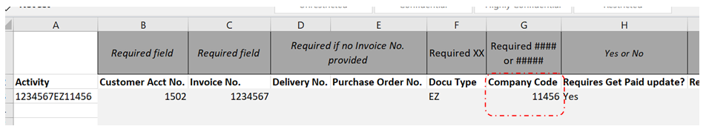

#### Bot processes Pharm Request

##### Determines invoice # from purchase order #

1. Launch SAP Galaxy portal
2. Run T-Code VA05
3. Enter Customer Acct No. in Sold-to Party field.
4. Enter purchase order # from Excel.
5. Delete any dates in Document Date.

Note: RTM will be QA instance and RPM will be Prod instance for Galaxy

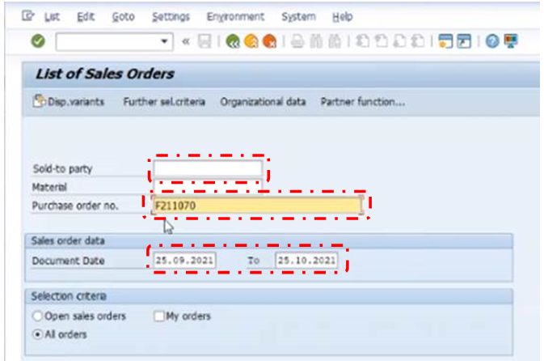

1. For the Organizational Data pop up window “Sales Organization, Distribution Channel, and Division need to be completed based off company code. EX: Spain - Sales Organization ES01, Distribution Channel: 01, Division: 01. Execute.

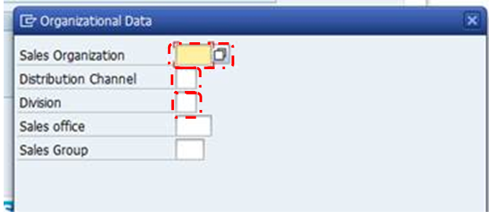

1. If no search results, then reply to Collector no results were found with the given inputs.,
2. If there are results, Select Document #. Double click

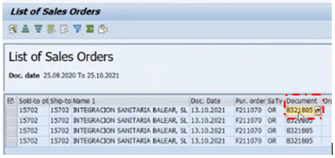

1. Select Standard order #. Select Document Flow.

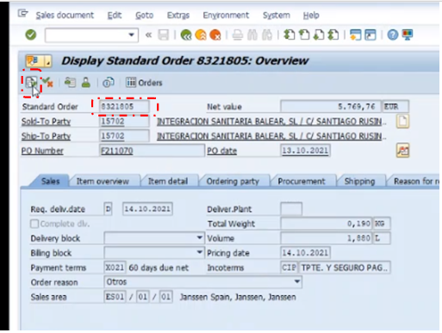

1. Find invoice # in document flow.

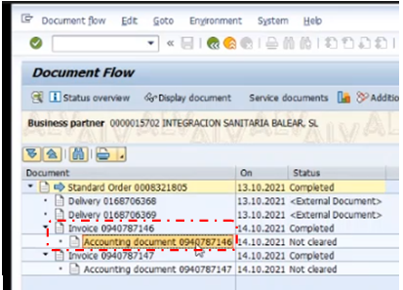

1. Update the Invoice # to BP processing file

##### Search for invoice copy via invoice #

1. Run VF31.
2. Set Output type “ESI1”, Processing mode “2”. Enter invoice #s in Billing document field.
3. Execute.

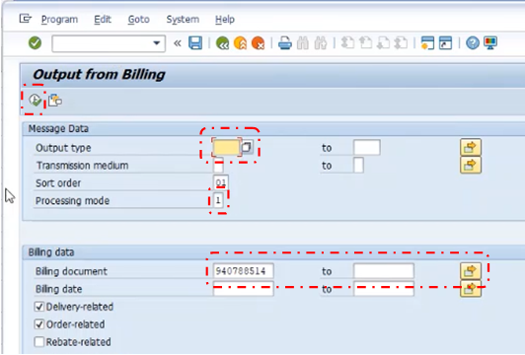

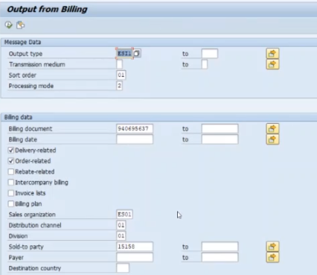

##### Save PDFs to local

If an invoice is not found for a customer account no. Reply back to Collector invoice was not found for given data. If results are found, Select the check box for the invoice #. Select Edit and select “Printer Default”.

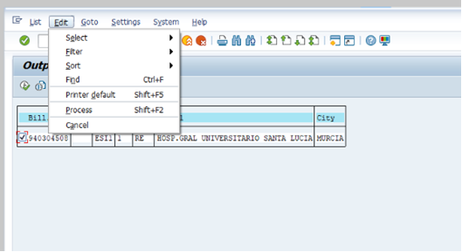

Select “PC-Local Printing” for Output Device. Select check box for Print immediately.

Select the green check mark. Windows settings need to have Microsoft Printer to PDF selected as default Printing method.

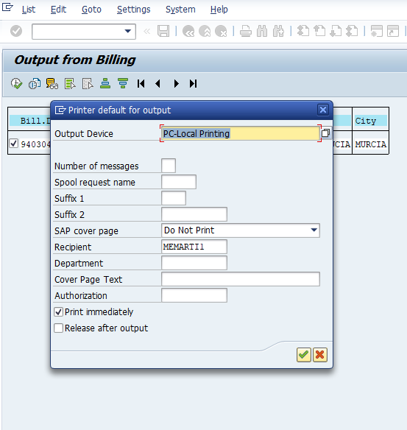

Select “Process”. The Invoice will turn green once complete.

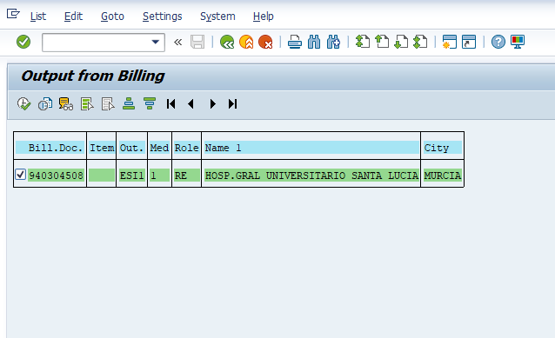

Browser window will pop up. Select pathway to download. Save to shared drive under download invoice folder ”\\eu.jnj.com\eudfsroot\jnjcz\FASE\3000\_ Receivable to Cash\RPA\BOT\EMEA Invoice Extract\Download Invoices\”

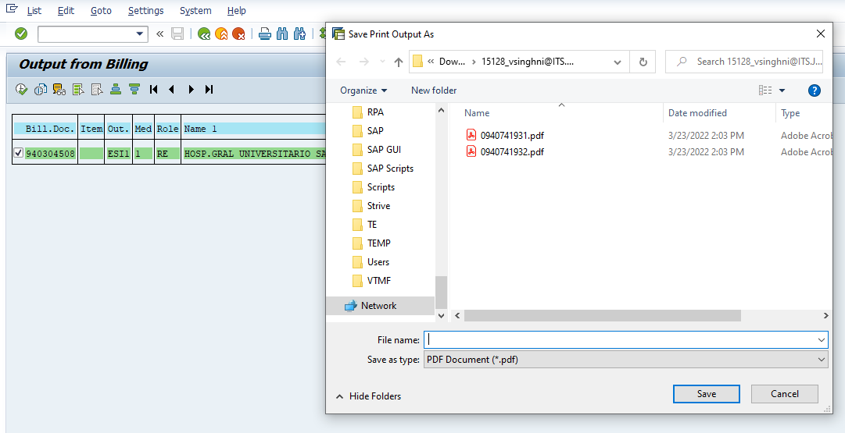

File name: Invoice #

##### Update SAP with confirmation invoice sent

If template has Yes for “Requires SAP update”

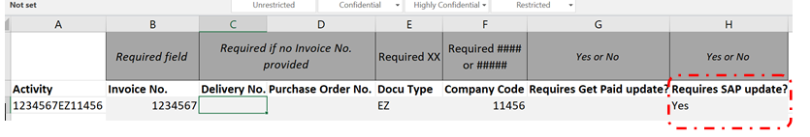

1. Using SAP Galaxy portal run T-Code YFT\_FFAR00.
2. Enter in company code and invoice number in Document Number field from input sheet. Execute.

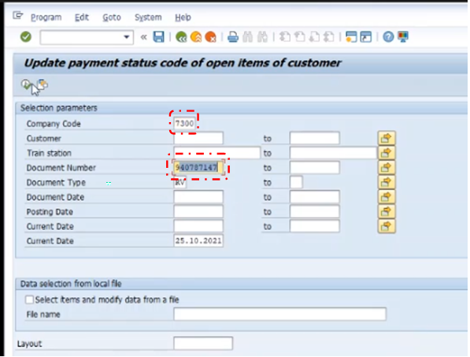

1. Select search result.
2. Select Update Items
3. Select check box for New Status Code and enter “5”.
4. Select check box for New Comment
5. Enter “Sent DD-MM-YYYY” for today’s date
6. Click check mark.

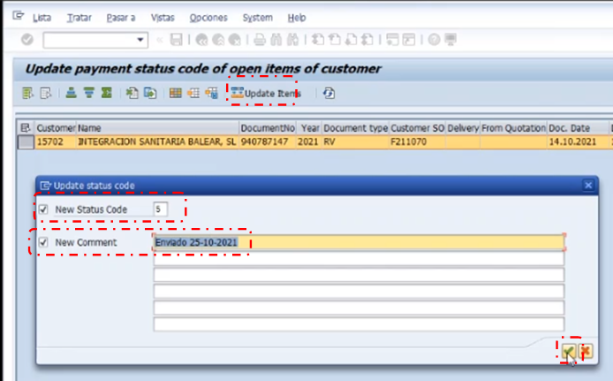

#### Bot processes MD P01 Request

##### Determine MD P01 and MD Mass Reprint requests

Use Document Type to determine MD P01 vs MD Mass Reprint requests

Note:

* + 1. P01 has document types FI, FM, VI, VM.
    2. All other document types are of MD Mass Reprint.

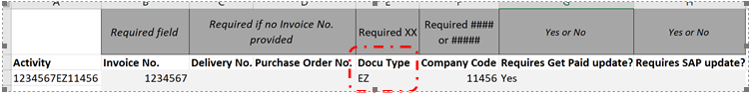

##### Searches for invoice or credit note

1. Launch SAP P01 portal.
2. Run T-Code “ZPDF”
3. Paste invoice number(s) or credit note(s) in No. Document field.
4. Select Output to local. Execute.

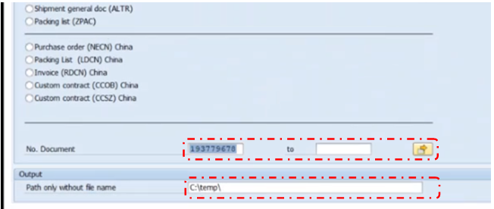

**Note: Use company code to determine region. For all Germany requests a “1” needs to be added in front of the invoice # or credit # to run successfully.**

**\*As we are only downloading PDF from SAP P01 instance. We are using P01(prod instance) since there is no update back to SAP.**

##### Saves PDF to local

Once processed successfully the location will pop up with PDFs.

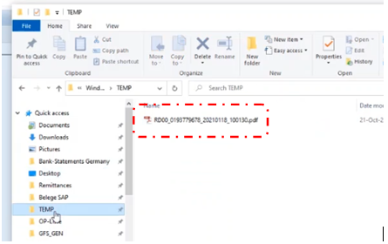

##### Bot processes Mass Reprint Request

1. Determine MD “MassReprint” requests from document type
2. Ensure mailbox email address is in pathway.
3. Update the folder path from config file in the pathway. If folder does not exist bot to create the folder. [\\EUBEOMP00A/nfsappFFP\append](file:///\\EUBEOMP00A/nfsappFFP\append) the path for each bot from config file
4. Add “Invoice No.-DocumentTypeCompanyCode” or “Credit Note-DocumentTypeCompany” depending on template inputs.
5. Different document numbers can be combined to the same request. Read all the data from Processing file where Request type is MR and Mass Print is 0 group by Email Address.
6. Save to local.

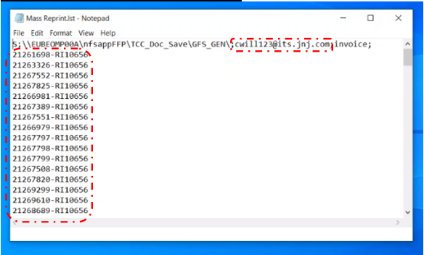

##### Drag & Drop to pathway

* Move saved template to [\\EUBEOMP00A/nfsappFFP\ES\_Mass\_Reprint](file://EUBEOMP00A/nfsappFFP/ES_Mass_Reprint)

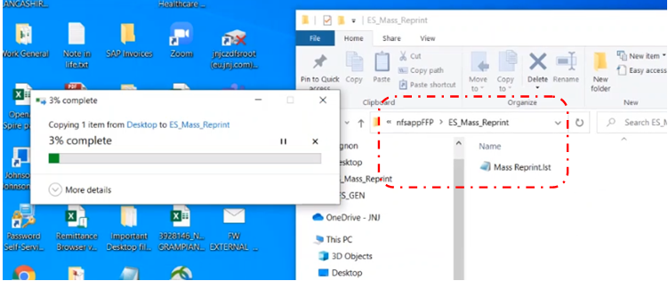

##### Saves PDF from email link

* Open email received from [MassReprintGenerator@formscape.jnj.com](mailto:MassReprintGenerator@formscape.jnj.com).
* Open link.
* Save PDFs to local.

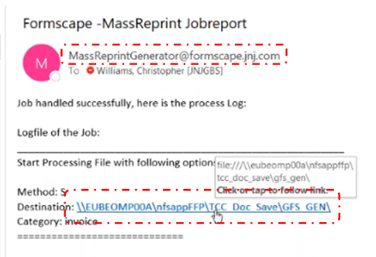

* If there are errors noted in errors occurred section in email, files didn’t run properly.

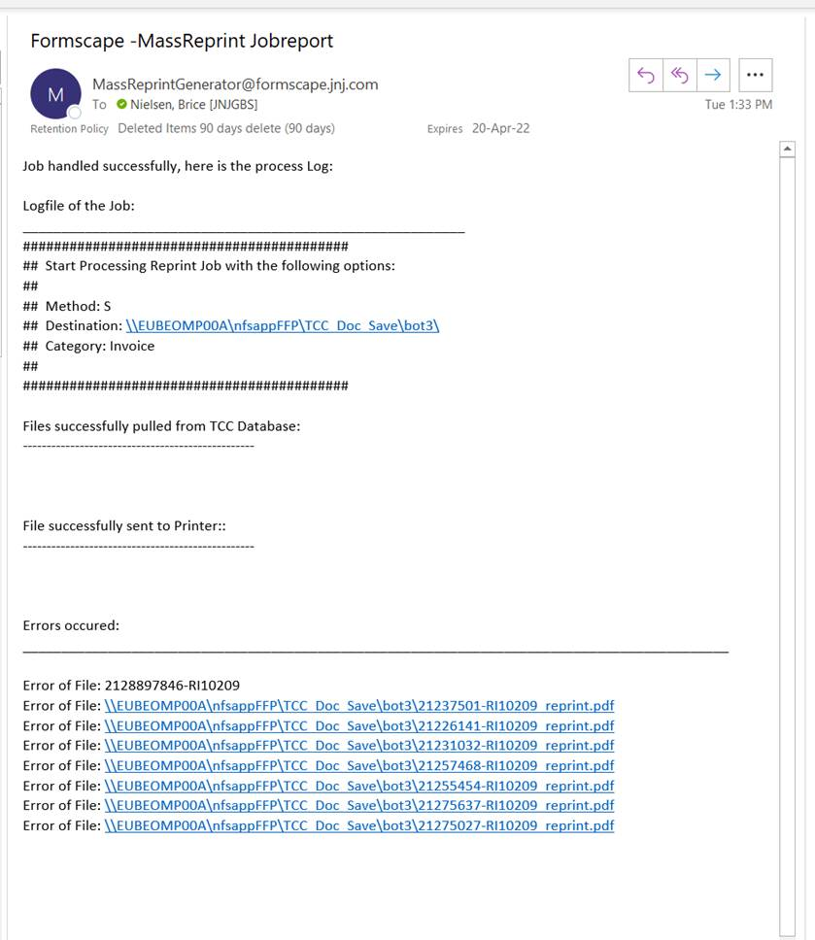



* Repeat dragging and dropping the template (a-c). (Max retry 10 times)
* Confirm data in files extracted.
* Confirm # of invoice requested vs processed.

#### Bot creates list of updates for Get Paid

* Identify an invoice update in Get Paid from template received.
  + If “Requires Get Paid update” is Yes, then
    - Bot to consolidate all requests that need to be updated in Get Paid.
    - Bot will create a file “GetPaid” with all the provided inputs received from Collector.
    - Bot will deposit file end of day into Shared Drive.

\\eu.jnj.com\eudfsroot\jnjcz\FASE\3000\_ Receivable to Cash\RPA\BOT\EMEA Invoice Extract\Getpaid Update\

#### Consolidate files

1. If template is Yes for “Consolidate invoices”, all PDF files from the template need to be consolidated into one PDF file and send back to the Collector.

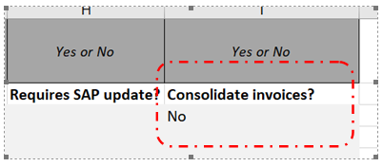

1. Launch Adobe Acrobat Pro. Select Combine Files into PDF.

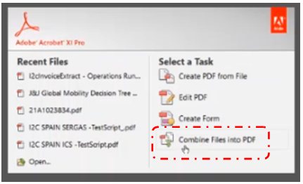

1. Select Add Files. Select Folder where PDFs are located. Select OK

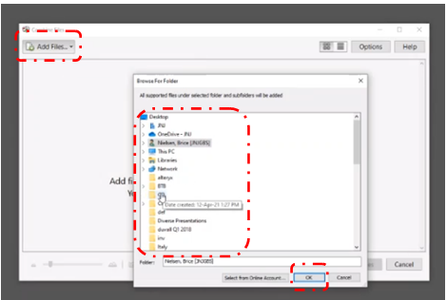

1. Click Combine Files

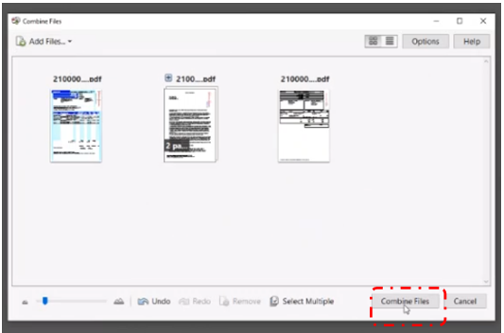

1. New combined PDF will open once finished processing. Once open, select Save As. Enter in “Combined Invoices\_MMDDYYYY\_HHMM” Save with the current date and time of completion.

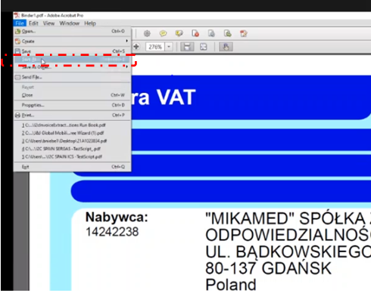

1. Click Save

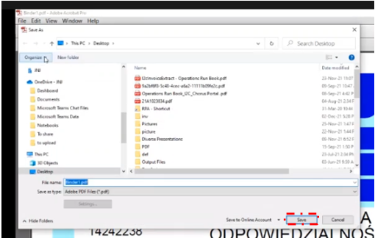

#### Email invoice back to collector

Bot creates email replying to Collector with PDFs downloaded for invoice request.

* Bot will reply with the pdf as attachment once all the line items from the input excel received from the collector is processed.

1. Filter the email id of collector, check if status is either Completed or Exception from Processing Sheet
2. Then reply to the mail with PDF as attachment
3. Else bot to process next line item from BP Queue.

* Bot to retrieve the email id of collector from Processing sheet
* Bot should find/filter the mailbox with email-id and date time.
* If number of pdf’s are more than 10, bot to send multiple emails with max of 10 pdfs as attachment.

## Bot Solution Design

* Bot will be designed to support Single-Bot and Multi-Bot Environment
* In Multi-Bot Environment, Bot would implement lock mechanism when Multiple Bots attempt to Load Queue, read Config, update summary report at same time.
* Bot will be scheduled on Working days from Monday to Friday. Business team would have to inform prior to the Support team if Bot must start an Ad-hoc run on-need basis
* Work Queue Tagging and Status would be updated for each transaction as below:
* Bot will maintain all transaction items in Bot Processing sheet to be stored in Share Drive. This Sheet will maintain all transaction item for entire day with current status



1. InProgress Transaction
   * + 1. Status – “INPROGRESS”
2. Completed Transaction
3. Status – “COMPLETED”
4. Tag – “COMPLETED”
5. Exception Transaction (Business and System Exception)

* Exception Reason – Exception Name (Exception Details are not included)
* Status – “EXCEPTION”
* Bot will not process the Failed Transaction from the previous run. It would be Manually processed by Business Team.
* If three consecutive transactions have the same System Exception, bot will not proceed on further transactions. It would send email to Support Team on the exception details and stop the process. In Multi-Bot environment, Remaining bots would handle the Pending Transactions.
* If any error encountered in a transaction, Business Exception are captured in Business exception, System Exception are captured in system Exception Log File.
* Bot will apply the retry logic for any System Exception for maximum attempt before it marks that transaction as exception. Maximum Retry number is configurable in Process Config File. Timeout seconds used in Wait logic should be configurable.
* Shared mailbox should be configured with folders Completed, Exception and In Progress. Bot to move the emails to respective folder based on status.

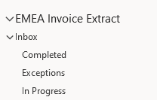

* Similar folder structure (InProgress, Completed, Exception) should be maintained within Share drive and bot to move the Excel Input template to respective folder based on status
* P01 has document types of FI, FM, VI, VM all to be configured in the Config file

10. Below is the approach on System Exceptions:

* 1. If a System Exception is encountered on transaction level, bot will trigger email on the Error immediately to Support team attaching the Exception Log File. Error Details will be logged into a Log File and bot would continue with next transaction.
  2. If a System Exception had occurred related to environment issue (For e.g., SAP application fails to launch), Bot would send email immediately to Support team with error details and stop the process.

11. Input Parameters for the Process are Configured in Process Config File (Excel). Folder Path and File Path of this Config File are configured as Environment Variables for the Process.

12. Template for System Exception Log File is maintained in Reference Folder. Bot will create a copy of this template file for each of its run with Date added as prefix to filename. Date Format will be ‘yyyy-mm-dd’.

13. Bot will implement Smart waits and will try to avoid using of arbitrary waits on the automation.

#### Single or Multi-Bot Solution

This solution is designed adhering to the principle of multiple bot solution

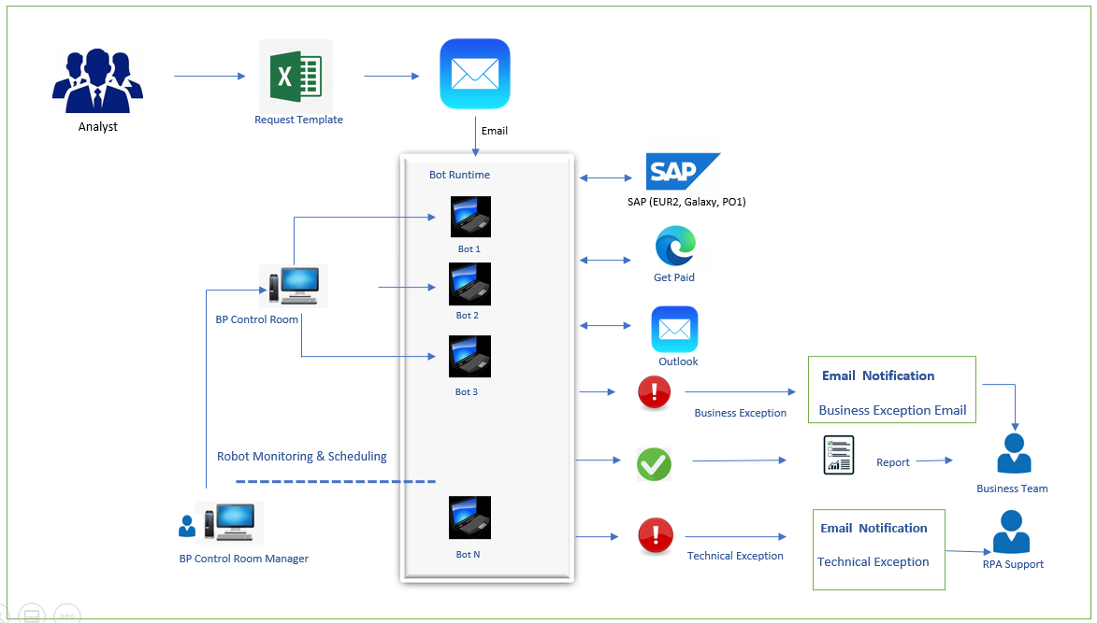

#### Application Availability

|  |  |  |  |
| --- | --- | --- | --- |
| Target Applications | Availability | Maximum Transaction Limit | Maximum Concurrent |
| SAP (Galaxy, EUR2 & P01) | 24x7 - No planned downtime | No Limit | 1 per session |
| Mass Reprint | 24x7 - No planned downtime | No Limit | 1 per session |
| Shared Drive | 24x7 - No planned downtime | No Limit | 1 per session |
| MS Outlook | 24x7 - No planned downtime | No Limit | 1 per session |
| MS Excel | 24x7 - No planned downtime | No Limit | 1 per session |

#### Bot Runner Requirement (Based on AS-IS Input)

Note: The build team should revisit the time taken by bot to process each Transaction during QA runs and alter the bot

|  |  |  |  |  |  |  |  |  |
| --- | --- | --- | --- | --- | --- | --- | --- | --- |
| **Process Name** | **Monthly** | **AS-IS FTE** | **AHT (Mins.)** | **Time Required to Manage Monthly Volume** | **System Uptime (Hrs.)/day** | **Bot Run Time (Hrs.)** | **No. of Bot Runners Required (Weekly) –Assuming 1-day operation** | **Comments** |
| **Volume** |
| EMEA Invoice Extract & Deliver process | 2000 | 70 | 4 mins | 133.33 Hours | 23 hrs. | 12 Working Hrs. | 0.51 | We shall revisit the time taken by bot to process each Invoice Request during QA runs and alter the bot schedule as needed |

**Note**: Request sent during business hours should be completed within same day and request sent later in the day can be completed next day. SLA to be maximum 12 hours

# Exceptions

## Known Exceptions

|  |  |  |  |
| --- | --- | --- | --- |
| Exception Name | Exception Type | Exception Description | How to Handle |
| BE-INFO-Invoice  Request from  Non-JNJ Account | Business  Exception | Invoice Request  not received from JNJ  account mails | • Bot will move the email to exception folder. • Bot will continue with reading the next email in Bot Mailbox. |
| BE-VALIDATION Invalid Invoice  Number, Delivery Number and Purchase Order Number | Business  Exception | Invoice Number. Or Delivery Number or Purchase Order Number is required | • Bot will send email Immediately to Collector • Bot will continue with reading the next Line item in BP Queue. |
| BE-VALIDATION Delivery Number Validation | Business  Exception | Document type should be 2 chars | • Bot will send email Immediately to Collector  • Bot will continue with reading the next Line item in BP Queue. |
| BE-VALIDATION Company code Validation | Business  Exception | Company code should be 4- or 5-digits number. | • Bot will send email Immediately to Collector. • Bot will continue with reading the next Line item in BP Queue. |
| BE-INPUT- Input Excel Format | Business  Exception | Input Excel was not in  Standard format | • Bot will send email Immediately to Collector. • Bot will continue with reading the next email in Bot Mailbox. |
| BE-OUTPUT- No search results | Business  Exception | No Search Results Found after running query | • Update the processing sheet with the exception details. • Bot will send email Immediately to Collector. • Bot will continue with reading the next Line item in BP Queue. |
| SE-IL-SAP (Galaxy, & P01)- failed  to launch | System Login  Exception | SAP (Galaxy & P01) Application  Failed to Launch | The task will be re-tried for until maximum number of attempts. • Bot will send mail Immediately when it occurs to IT Team (DL-CONUS-JJT-RPA-SUPPORT@ITS.JNJ.com; DL-NCSUS-JJT-RPA-PLATFORM@ITS.JNJ.com). The message should contain the step of the process, Application concerned and a print screen of the issue if possible • Bot will stop the task |
| SE-IL-SAP (Galaxy, & P01)- failed  to Login | System Login  Exception | SAP (Galaxy & P01) Application  Failed to Login | The task will be re-tried for until maximum number of attempts. • Bot will send mail Immediately when it occurs to IT Team (DL-CONUS-JJT-RPA-SUPPORT@ITS.JNJ.com; DL-NCSUS-JJT-RPA-PLATFORM@ITS.JNJ.com). The message should contain the step of the process, Application concerned and a print screen of the issue if possible • Bot will stop the task |
| SE-SETO-Missing  Value | System  Exception  Try Once | Missing Value in Process Config File | • IF the Exception had occurred in the Work Queue  transaction, then  Log the System Exception details to Log file. The message should contain the step of the process, Application concerned and a print screen of the issue if possible. o Continue with Next Work Item in Queue Else o Bot will send mail Immediately when it occurs to IT Team (DL-CONUS-JJT-RPA-SUPPORT@ITS.JNJ.com; DL-NCSUS-JJT-RPA-PLATFORM@ITS.JNJ.com).  o Bot will stop the task. |
| SE-SU-Share Drive Folder Inaccessible | System Unavailable Exception | Share Drive not Accessible | The task will be re-tried for until maximum number of attempts. • IF the Exception had occurred in the Work Queue transaction, then  Log the System Exception details to Log file. The message should contain the step of the process, Application concerned and a print screen of the issue if possible. o Continue with Next Work Item in Queue Else o Bot will send mail Immediately when it occurs to IT Team (DL-CONUS-JJT-RPA-SUPPORT@ITS.JNJ.com; DL-NCSUS-JJT-RPA-PLATFORM@ITS.JNJ.com).  o Bot will stop the task. |
| SE-SU-Outlook Inaccessible | System Unavailable Exception | Outlook not Accessible | The task will be re-tried for until maximum number of attempts. • IF the Exception had occurred in the Work Queue transaction, then o Log the System Exception details to Log file. The message should contain the step of the process, Application concerned and a print screen of the issue if possible. o Continue with Next Work Item in Queue Else o Bot will send mail Immediately when it occurs to IT Team (DL-CONUS-JJT-RPA-SUPPORT@ITS.JNJ.com; DL-NCSUS-JJT-RPA-PLATFORM@ITS.JNJ.com).  o Bot will stop the task. |
| SE-SU-MS ExcelInaccessible | System Unavailable Exception | MS Excel not Accessible | The task will be re-tried for until maximum number of attempts. • IF the Exception had occurred in the Work Queue transaction, then o Log the System Exception details to Log file. The message should contain the step of the process, Application concerned and a print screen of the issue if possible. o Continue with Next Work Item in Queue Else o Bot will send mail Immediately when it occurs to IT Team (DL-CONUS-JJT-RPA-SUPPORT@ITS.JNJ.com; DL-NCSUS-JJT-RPA-PLATFORM@ITS.JNJ.com).  o Bot will stop the task. |
| SE-SU-AdobeAcrobatInaccessible | System Unavailable Exception | Adobe Acrobat DC not accessible | The task will be re-tried for until maximum number of attempts. • IF the Exception had occurred in the Work Queue transaction, then o Log the System Exception details to Log file. The message should contain the step of the process, Application concerned and a print screen of the issue if possible. o Continue with Next Work Item in Queue Else o Bot will send mail Immediately when it occurs to IT Team (DL-CONUS-JJT-RPA-SUPPORT@ITS.JNJ.com; DL-NCSUS-JJT-RPA-PLATFORM@ITS.JNJ.com).  o Bot will stop the task. |

## Unknown Exceptions

|  |  |  |
| --- | --- | --- |
| Exception Name | Exception Type | How to Handle |
| SE-UNKNOWN- <<Unhandled  Exception >> | System Exception | • The task will be re-tried for until maximum number of attempts. • Bot will send mail Immediately when it occurs to IT Team (DL-CONUS-JJT-RPA-SUPPORT@ITS.JNJ.com; DL-NCSUS-JJT-RPA-PLATFORM@ITS.JNJ.com). The message should contain the step of the process, Application concerned and a print screen of the issue if possible.  • IF the Exception had occurred in the Queue transaction, then, o Log the System Exception details to Log file. The message should contain the step of the process, Application concerned and a print screen of the issue if possible. o Continue with Next Work Item in Queue Else o Bot will send mail Immediately when it occurs to IT Team (DL-CONUS-JJT-RPA-SUPPORT@ITS.JNJ.com; DL-NCSUS-JJT-RPA-PLATFORM@ITS.JNJ.com). o Bot will stop the task. |

# Object Design

## Shared Objects

|  |  |
| --- | --- |
| Shared Object Name | Actions Called |
| MS Excel VBO | Get Worksheet as Collection |
| MS Outlook VBO | Check access to Mailbox / Send Email/Reply to Email / Move to Folder / Save Attachment |
| Utility – Collection Manipulation | Set Collection Field / Delete Field /Add Row / Append Field |
| Utility-String | Split Text |
| Utility – File Management | Write Text File |

### Shared Object Changes

|  |  |
| --- | --- |
| Object Name | NA |
| Action Name |  |
| Proposed Change |  |
| Reason for Change |  |
| Impact Assessment |  |

## Custom Objects

|  |  |  |  |
| --- | --- | --- | --- |
| Object Name | JJ\_I2C\_SAP\_Extract Invoice | | |
| Object Description | This object is responsible to extract invoice number and downloading PDF | | |
| Object Type | Custom | | |
| Action Name | Purpose | Input | Output |
| SAP: EnterTCode | This page is responsible to run TCODE | In\_TCode | N/A |
| SAP VA05 | This page is responsible to extract invoice number from purchase order number | CustomerNum, Channel, Division, PurchaseOrderNo, SalesOrg, SearchText | FinalInvoice |
| Filter Collection: One Column |  | ColPRocessing,column | Output |
| EmailBodyRead |  | EmailBody, textToSearch | Count |
| SAP VF31 | This page is responsible to download PDF from invoice number | BILLINGDOCUMENT, CUSTOMERNUM, DISTRIBUTIONCHANNEL, DIVISION, OUTPUTTYPE, PROCESSINGMODE, SALESORG, OutputDevice | Output |
| SAP VF31Exit | This page is responsible to perform exit from VF31 | NA | NA |
| SAP YFT\_FFAR00 | This page is responsible to update the status code and comment for given invoice number | CompanyCode, InvoiceNum, StatusCode, Comment | Output |
| SAP ZPDF |  | In\_Path | textData |
| ConnectStringDB |  | Coll1, ColName | Out\_Format |
| ConvertStringCommaSeparator |  | InputCollection, ColumnName | OutString |

|  |  |  |  |
| --- | --- | --- | --- |
| Object Name | JJ\_I2C\_Merge\_PDF | | |
| Object Description | This object is responsible for consolidating PDF | | |
| Object Type | Custom | | |
| Action Name | Purpose | Input | Output |
| Attach | This page is responsible for attaching PDF instance | File path | NA |
| Merge PDF | This page is responsible for performing any steps associated with merging PDF | Company Code, Document Number, Current Date | NA |
| Consolidate PDF | This page is responsible to perform steps to combine multiple PDF to one | File Path | NA |
| Save PDF | This page is responsible for saving merged PDF in Share Drive | File Path | NA |

|  |  |  |  |
| --- | --- | --- | --- |
| Object Name | JJ\_I2C\_OLEDB\_Query | | |
| Object Description | This object is responsible for querying database to validate input request | | |
| Object Type | Custom | | |
| Action Name | Purpose | Input | Output |
| Open Connection | This page is responsible for connecting to database instance | ***Connection String***  Provider=OraOLEDB.Oracle.1;data source=E1L0000036.JNJ.COM:1521/GMED\_RO.JNJ.COM; User Id= User ID; Password= Pwd; |  |
| Close Connection | This page is responsible for terminating existing DB connection | DB connection string |  |
| Execute Query | This page is responsible to run query with Invoice numbers | Select rpan8 "Customer", rpdoc "Doc Nr", rpdot "Doc Type", from proddta.f03b11 where rpan8 = 'Customer Acct No' and rpdoc in ( 'Invoice Numbers') | Output table |

|  |  |  |  |
| --- | --- | --- | --- |
| Object Name | JJ\_EMEAInvoice\_SAP\_Login | | |
| Object Description | This object is responsible to check if SSO is performed using ERP launchpad | | |
| Object Type | Custom | | |
| Action Name | Purpose | Input | Output |
| SAP Login Non-SSO | This page is responsible to login into SAP using credentials | WindowTitle, Username, Client, Language, Password | N/A |
| SSO Check | This page is responsible to check if SSO is performed | WindowTitle | N/A |
| Detach | This page is responsible to detach the SAP instance | N/A | N/A |
| SAP\_Logoff | This page is responsible to perform SAP log off | WindowTitle | N/A |
| SAP\_LogonClose | This page is responsible to close the SAP logon | WindowTitle | N/A |

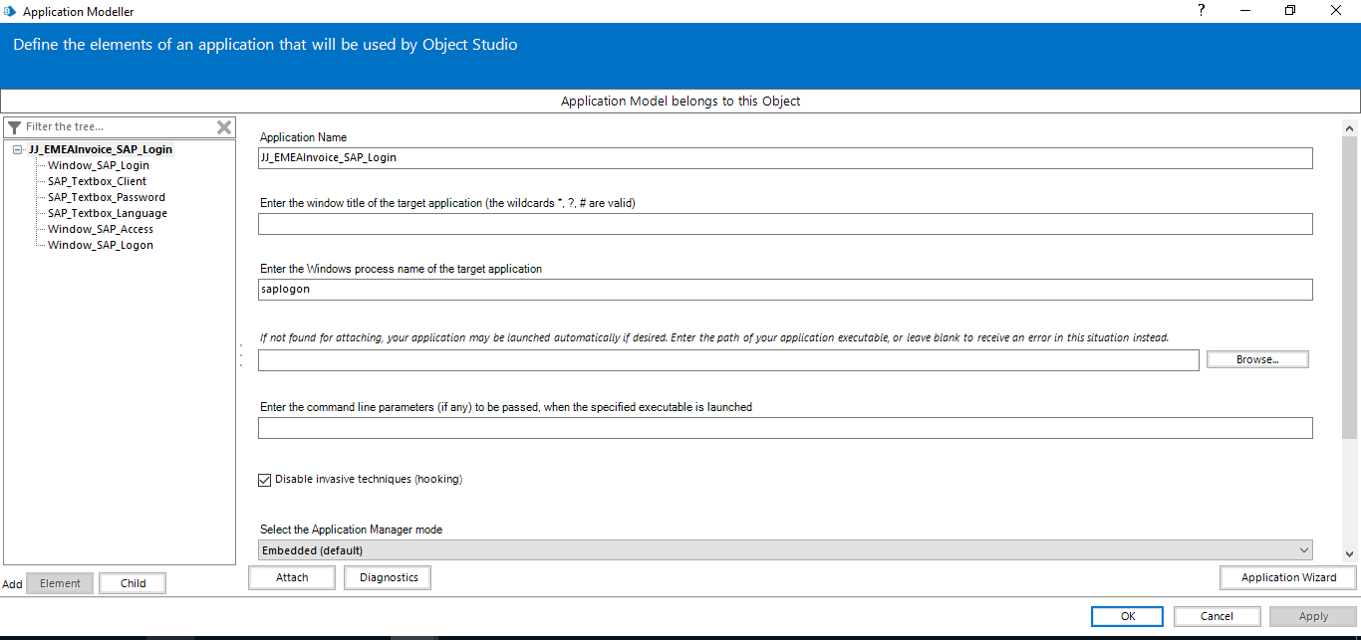

|  |  |  |  |
| --- | --- | --- | --- |
| Object Name | JJ\_ERP\_Launchpad\_Chrome | | |
| Object Description | This object is responsible to launch and login into ERP launchpad | | |
| Object Type | Standard | | |
| Action Name | Purpose | Input | Output |
| Launch | This page is responsible to launch ERP Launchpad application | URL | N/A |
| Attach | This page is responsible to attach the instance of ERP launchpad | WindowLogin,ProcessName | Connected |
| Login | This page is responsible to perform login into ERP launchpad | IsConnected | N/A |
| Filter SAP Instance | This page is responsible to filter the SAP instance which needs to be logged in | SAPInstance, ProcessName, WindowTitle | N/A |
| Logout | This page is responsible to perform the SAP logout | WindowLogin,ProcessName | N/A |
| OpenSAPInstance | This page is responsible to open the downloaded SAP instance | WindowLogin,ProcessName | N/A |

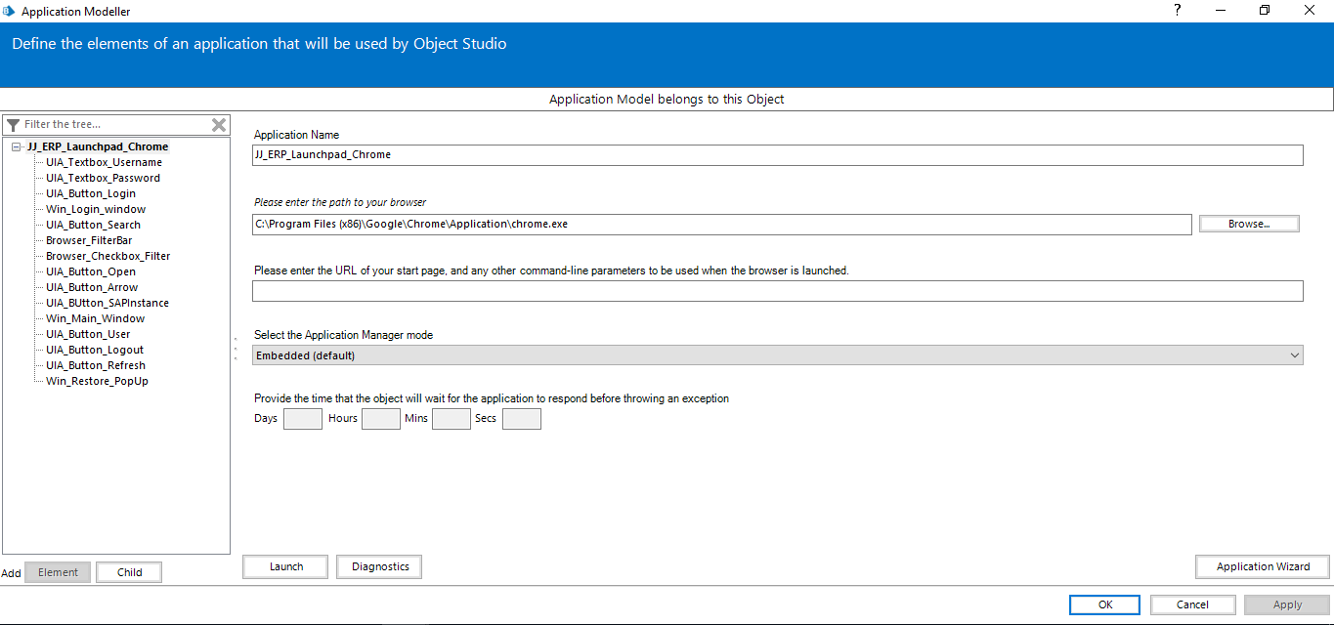

# Data

## Environment Variables

|  |  |  |  |
| --- | --- | --- | --- |
| Variable Name | Data Type | Value | Description |
| ENV\_GL\_FIN\_I2C\_InvoiceExtraction\_ApplicationCI | Text | N/A | InvoiceExtraction Application CI |
| ENV\_GL\_FIN\_I2C\_InvoiceExtraction\_ClientCode | Text | 050 | Contains client code value |
| ENV\_GL\_FIN\_I2C\_InvoiceExtraction\_EmailTo | Text | DL-CONUS-JJT-RPA-SUPPORT@ITS.JNJ.com | Contains support email address |
| ENV\_GL\_FIN\_I2C\_InvoiceExtraction\_IRISTicketCreation | Flag | True | IRIS Ticket Creation Flag |
| ENV\_GL\_FIN\_I2C\_InvoiceExtraction\_ProcessConfigFileName | Text | ProcessConfig.xlsx | Process Config File Name |
| ENV\_GL\_FIN\_I2C\_InvoiceExtraction\_ProcessConfigFolderName | Text | \\eu.jnj.com\eudfsroot\jnjcz\FASE\3000\_ Receivable to Cash\RPA\BOT\EMEA Invoice Extract\ProcessConfig\ | Process Config Shared Path |
| ENV\_GL\_FIN\_I2C\_InvoiceExtraction\_ProcessConfigLocalPath | Text | D:\TEMP\ | LocalPath of bot machine |
| ENV\_GL\_FIN\_I2C\_InvoiceExtraction\_ResourceWWID | Text | N/A | InvoiceExtraction Resource WWID |
| ENV\_GL\_FIN\_I2C\_InvoiceExtraction\_TemplatePath | Text | \\eu.jnj.com\eudfsroot\jnjcz\FASE\3000\_ Receivable to Cash\RPA\BOT\EMEA Invoice Extract\Template\ | Template folder path |
| ENV\_GL\_FIN\_I2C\_InvoiceExtraction\_ProcessingSheet | Text | \\eu.jnj.com\eudfsroot\jnjcz\FASE\3000\_ Receivable to Cash\RPA\BOT\EMEA Invoice Extract\Daily Processing\ProcessingFile.xlsx | Contains Processing File Name |

## Session Variables

|  |  |  |  |
| --- | --- | --- | --- |
| Variable Name | Data Type | Value | Description |
| IsStopRequested() | Flag | False | Flag to indicate whether to stop after current case has completed using “IsStopRequested()” |
| isLoggingEnabled | Flag | False | Flag to indicate if process can write process logging text file. (Used for firefighting) |

# Credentials

This section captures required credential details for domains and applications for the solution.

**All credentials will be encrypted and stored within Blue Prism credential manager. Business objects will be used to retrieve credentials. These will never be logged, and passwords will always be encrypted on Blue Prism.**

Bot should have access to all the target application. The accesses should have the same permission as the agent working on the business process. Business Team will manage the Bot ID and take care of Password Expire Policy.

## Credential Management

|  |  |  |
| --- | --- | --- |
| Credential Name | Description | Expiry |
| Bot ID | SSO for DEV, PROD and QA SAP-Galaxy, and SAP-P01 applications  Login Username and Password. Credentials will not be managed by bot | Platform administration team will Manage the Credentials and own the Password Expire Policy |
| OLEDB-PROD-I2C\_RPA\_PD | Username and password to establish OLEDB connection | Service account will be used and Business point of contact to manage credentials |

## Application Access Details

|  |  |
| --- | --- |
| Application Name | SAP - Galaxy |
| Access Request Key Contact | Issue presented to Brice (bnielse1@ITS.JNJ.com). They submit a ticket to SAP team |
| Password Expire Policy | Domain / Application expiry policy |
| Password Reset Process | NA |
| Login Method | SSO |

|  |  |
| --- | --- |
| Application Name | SAP – P01 |
| Access Request Key Contact | Issue presented to Brice (bnielse1@ITS.JNJ.com). They submit a ticket to SAP team |
| Password Expire Policy | Domain / Application expiry policy |
| Password Reset Process | NA |
| Login Method | SSO |

|  |  |
| --- | --- |
| Application Name | OLEDB |
| Access Request Key Contact | Issue presented to Brice ([bnielse1@ITS.JNJ.com](mailto:bnielse1@ITS.JNJ.com)) for access to Prod and Dev |
| Password Expire Policy | NA |
| Password Reset Process | Issue presented to Brice (bnielse1@ITS.JNJ.com). |
| Login Method | Non - SSO |

## Application Installation

Install below application component for Oracle OLEDB connection

|  |  |
| --- | --- |
| Application Name | Oracle Data Access Components (ODAC) x64 v19.3 (JNJ0139F)  Oracle Data Access Components (ODAC) v19.3 (JNJ01354) |

## Target Applications Access

Target applications and access levels of the BOT are detailed below:

|  |  |
| --- | --- |
| Target Applications | Access Levels |
| MS Outlook 2016 | SSO |
| Shared Drive Folder | SSO with Read, Delete, Write |

# Reporting and Monitoring

* Bot Sends email to collector on completion of each input file
* Each line item from input file will be added in processing file and updates the status
* Exception log file will be maintained incase of exceptions on daily basis

# Alerts

The following parties will receive an email notification under the following circumstances.

* Where the process is unable to login to any of the systems, an email will be sent.
* Where a system exhibits unfamiliar behaviour, the blue prism process will probably encounter a pattern of system exception. Where 3 consecutive system exceptions are encountered, the process will stop under the presumption that the system has a problem.
* When the automation failed on unknown/unhandled exception and not able to understand next step.

In different case of exceptions, mails will be triggered to the email id’s which will be shared by the business.

## Controller/Admin

The following process notification emails are sent to resource(s) responsible for managing the solution through the Control Room.

|  |  |
| --- | --- |
| Scenario | Recipients |
| Process Completion Status | None |
| Business Exception | Requestor’s Email Address |
| Known System Exception | [DL-CONUS-JJT-RPA-SUPPORT@ITS.JNJ.com](mailto:DL-CONUS-JJT-RPA-SUPPORT@ITS.JNJ.com) |
| Unknown System Exception | [DL-CONUS-JJT-RPA-SUPPORT@ITS.JNJ.com](mailto:DL-CONUS-JJT-RPA-SUPPORT@ITS.JNJ.com) |

## Process Owners

The following process notification emails are sent to the process owners as a management information feature.

|  |  |
| --- | --- |
| Scenario | Recipients |
| Process Completion Status | Requestor’s Email Address |

## Support Team

The following process notification emails are sent to the process owners as a management information feature.

|  |  |
| --- | --- |
| Scenario | Recipients |
| Known System Exception | [DL-CONUS-JJT-RPA-SUPPORT@ITS.JNJ.com](mailto:DL-CONUS-JJT-RPA-SUPPORT@ITS.JNJ.com) |
| Unknown System Exception | [DL-CONUS-JJT-RPA-SUPPORT@ITS.JNJ.com](mailto:DL-CONUS-JJT-RPA-SUPPORT@ITS.JNJ.com) |

# Management Reporting Details

Bot to upload XXX which includes details by transaction of how many invoices are downloaded, Collector Email Address, time etc.

# Operational and Deployment Requirements

## Schedule and Operating Hours

|  |  |  |  |  |
| --- | --- | --- | --- | --- |
| Schedule Number | Activity | Scheduling Time | Timeline Guidelines (if applicable) | Frequency |
| CORP\_GL\_FIN\_I2CInvoiceExtraction\_Scheduler | Trigger the Bot to Perform Invoices | 7:00 AM CET – 6:00 PM CET; | Central European Time Zone | Monday to Friday |

# Application Model

Application Name: JJ\_ERP\_Launchpad\_Chrome

Path of the Application or executable: C:\Program Files (x86)\Google\Chrome\Application\chrome.exe

Command line parameters: NA

Target Application Working Directory: NA

Element Tree:

|  |  |  |
| --- | --- | --- |
| **Element Name** | **Parent Element Type** | **Highlighted Screenshot** |
| UIA\_Textbox\_Username | Text | N/A |
| UIA\_Textbox\_Password | Text | N/A |
| UIA\_Button\_Login | Button | N/A |
| Win\_Login\_window | Window | N/A |
| UIA\_Button\_Search | Button | N/A |
| Browser\_FilterBar | Text | N/A |
| Browser\_Checkbox\_Filter | Web Element | N/A |
| UIA\_Button\_Open | Button | N/A |
| UIA\_Button\_Arrow | Button | N/A |
| UIA\_BUtton\_SAPInstance | Button | N/A |
| Win\_Main\_Window | Window | N/A |
| UIA\_Button\_User | Button | N/A |
| UIA\_Button\_Logout | List Item | N/A |
| UIA\_Button\_Refresh | Button | N/A |
| Win\_Restore\_PopUp | Window | N/A |

Application Name: JJ\_EMEAInvoice\_SAP\_Login

Path of the Application or executable: C:\Program Files (x86)\SAP\FrontEnd\SAPgui\saplogon.exe

Command line parameters: NA

Target Application Working Directory: NA

Element Tree:

|  |  |  |
| --- | --- | --- |
| **Element Name** | **Parent Element Type** | **Highlighted Screenshot** |
| Window\_SAP\_Login | Window | N/A |
| SAP\_Textbox\_Client | SAP Textbox | N/A |
| SAP\_Textbox\_Password | SAP Password | N/A |
| SAP\_Textbox\_Language | SAP Textbox | N/A |
| Window\_SAP\_Access | Window | N/A |
| Window\_SAP\_Logon | Window | N/A |

# Information Security and Risk Management

## Business Continuity Plan

Business team will follow the below BCP based on the scenario and nature of the issue.

|  |  |  |
| --- | --- | --- |
| S No. | Scenario | BCP |
| 1 | SAP Not Connected or Downtime | Bot will Report Issue to IT Team by Sending email to (email) Business Team will have to take the decision to run the process Manually or trigger bot Manually once Portal is up. |
| 2 | Resource (VM) is Offline | Based on Scheduler Configuration in BP, it will perform Maximum retry (3) on the Offline Resource, Controller/Admin will monitor the BP Control Room and Report this issue Manually by sending email to Business Team Business Team will have to Run Manually for the Day. |
| 3 | Blue Prism Unavailability | Controller/Admin will monitor the BP Control Room and  Report this issue Manually by sending email to Business Team Business Team will have to Run Manually for the Day |

## Risk Management

|  |  |  |
| --- | --- | --- |
| Sl No | Risk | Mitigation |
| 1 | Failure due to changes in the SAP Screens | Bot will Report Issue to IT Team by Sending email to (email Address) Recovery Plan should be Implemented on the Change Request and its deadline. If timeline to complete the resolution will be beyond the internal deadline, Business Team must perform manually  the Process until Completion of the Change Request. |
| 2 | SharePoint or Outlook not Accessible | Bot will Report Issue to IT Team by Sending email to (email address) Business Team will have to Run Manually for the Day if Share Drive Folder or Outlook is not accessible for the entire day. |

## Information Security Audit and Compliance requirement

* + On Error, bot will ensure that only System Exceptions will have the Print Screen captured and not for Business Exceptions. File Path of the screenshot are updated to the System Exception Log file. Bot will ensure that Print Screen are not performed on Customer personal data. Business team should confirm that all Print Screen does not have sensitive data GDP Compliance team
  + Step level and transaction level logging that are stored in BP Database will be disabled in production
  + environment.
  + No other interim or temporary data will be preserved in the SharePoint folder or Blue Prism.
  + The solution will entail Blue Prism Work-Queue and Environment-Lock features, which will ensure concurrency, scalability, and recoverability
  + The KEY field (Entry ID) will be stored in the BP Work-Queue and will help in uniquely identifying a record, hence in-turn avoiding duplication.
  + Work Queue fields will be stored in the BP Work-Queue in the encrypted form.

## Logging

1. As per standard process, the bot will not store the step-level logs in the Blue Prism database.
2. When bot encounters a System Exception, it sends email immediately to the IT team attaching the Log File. System Exception Details will be logged into a Log File and saved at specific location on SharePoint.

# Data Validation

## Data Flow

The Following Work Queue(s) will be created for this process:

|  |  |  |  |
| --- | --- | --- | --- |
| ID | Process Name | Queue Name | Description |
| 1 | GL\_FIN\_I2C\_InvoiceExtraction | CORP\_GL\_FIN\_I2CInvoiceExtraction\_Queue | This Work Queue Contains data related to Invoice Extraction Work Queue is Encrypted using the “Default Encryption Scheme” Key |

|  |  |  |  |
| --- | --- | --- | --- |
| ID | Field Name | Data Type | Description |
| 1. | Invoice Number | Number | Invoice or Document Number |
| 2. | PO Number | Number | PO Number |
| 3. | Delivery Number | Number | Delivery Number |
| 4. | Document Type | Text | Type of Document |
| 5. | Company Code | Number | Company Code |
| 6. | Get Paid Update | Flag | Flag value to validate if Get Paid update required |
| 7. | SAP Update | Flag | Flag value to validate if SAP update required |

# Additional Assumptions

## Technical

|  |  |  |
| --- | --- | --- |
| ID | Title | Description |
| 1 | Application Availability | All applications will be natively available to RPA studio or development server. |
| 2 | Application Changes | All changes to the target applications will be communicated to the Development and Support teams well in advance by Business Team. |
| 3 | Process Performance | Any major increase parameters affecting, process performance like volume, schedule, SLA will be defined by the Business Team in advance. |
| 4 | Infrastructure | All hardware, Software and Networking requirements along with infrastructure requirement in production, development and testing environment are to be taken care by Business Team. |
| 5 | BP environment | Blue Prism development environment and production should be identical |
| 6 | Application Licenses | Licenses of all the software's are procured by Business Team |
| 7 | Process Summary Report | Report Bot will send email with Process Summary at the end of the Process Completion |
| 8 | System Exception | Mail At the end of Bot execution, Bot will send a consolidated email to IT Support team attaching the Log File. Exception Log File is maintained that will capture all the Exception Details |
| 9 | Configure Bot1 Mailbox in all the Bot Machines | In a Multi-Bot environment, Bot1 Mailbox will be configured as default mailbox in all the Bot Machines |

## Business

|  |  |  |
| --- | --- | --- |
| ID | Title | Description |
| 1 | Process Config File Path | Process Configuration file path need to be configured in Blue |

# Revision History

| **Version** | **Date** | **Author** | **Change Descriptions** |
| --- | --- | --- | --- |
| 1.0 | 26/04/2021 | Elisa Longoria/ Vasundhara Singh Nirwan/Vijayakumar K | Initial draft/ Update MD P01 Mass Reprint Steps and Pharma Steps/Updated Process Steps |